Range Therapy developer manual
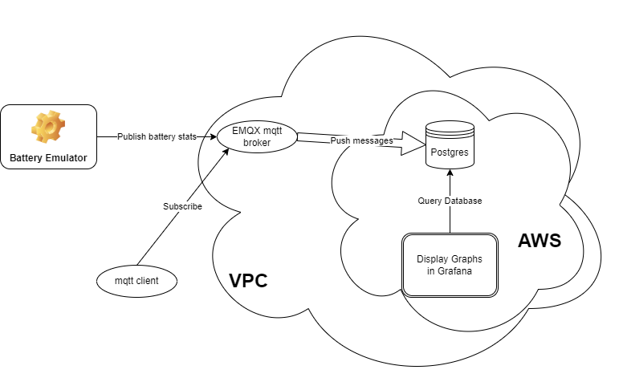

PC config
Install VSCode from https://code.visualstudio.com/download
Add the extensions C/C++, C/C++ Extension Pack and PlatformIO IDE
Install Git and Git Desktop (optional)
Install python 3
Clone repository from Github (currently at https://github.com/EncludeLtd/Battery-Emulator)

Useful tools
MQTTX client to monitor mqtt messages
Use the topic rangetherapy/sensor/# for all messages
Or
rangetherapy/sensor/+/info for general battery status
rangetherapy/sensor/+/events for events
rangetherapy/sensor/+/spec_data
The + stands for all clients, this may be replaced by the client id, in the development board this is battery-emulator_esp32-CFF924
pgAmin4 for database admin

EMQX platform
Login using https://accounts.emqx.com/signin
One deployment at j2ee4cd2.ala.dedicated.aws.emqxcloud.com port 1883 accepts all events pushed from the emulator(s)
Three rules are active
https://cloud-intl.emqx.com/console/deployments/j2ee4cd2/integrations/all/rule_details?id=rule-cf48a111 matches the /info messages
https://cloud-intl.emqx.com/console/deployments/j2ee4cd2/integrations/all/rule_details?id=rule-a586ed09 matches the /spec_data messages
https://cloud-intl.emqx.com/console/deployments/j2ee4cd2/integrations/all/rule_details?id=rule-111e1931 matches the /events messages
each rule has one action that takes the matching message, adds a timestamp, decodes the payload and sends the raw payload and the decoded fields to a Postgres database running on AWS
A virtual private cloud has been created to encapsulate the EMQX deployment, the Postgres database and the Grafana display package.

AWS Platform
This hosts the database and the Grafana display package
The database is at database-mqtt.cxmymmyeyegb.eu-west-1.rds.amazonaws.com
Grafana is at https://g-56ac810d1e.grafana-workspace.eu-west-1.amazonaws.com/dashboards
Login to EC2 is restricted to specified IP addresses – document how to add an address
To provide an SSH client for database admin, there is an instance of Amazon Lunix running in EC2, also within the VPC

Shortcut to dashboard https://g-56ac810d1e.grafana-workspace.eu-west-1.amazonaws.com/goto/2TaRd5zNg?orgId=1

Compiling the software
In usersettings.cpp, set the username and password for the mqtt user
const char* mqtt_user = "RangeTherapy";
const char* mqtt_password = look in lastpass
also set the battery used and remove Test_fake_battery
Build using the Build option in the Platform.io extension (alien icon)
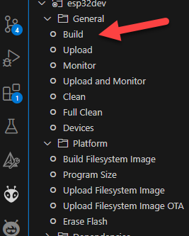
Send to the board using the Upload option.
When the board is connected to the USB port, Monitor allows you to see the debug messages
Once the board is running, connect to the Battery Emulator wifi, go to 192.168.4.1 and set the SSID and password for the host network.
Data should immediately start flowing to emqx

